House Sale price prediction comparing techniques of Regression, Ensemble methods & Neural Network

IE 7615: Neural Networks and Deep Learning Course Project Report
Sumit Gupta, Nirav Patel, Ameya Patankar
[gupta.sum, patel.nira, patankar.am]@husky.neu.edu

Abstract
In this project, we have worked on predicting the House sale price based on several features available on the popular Ames, Iowa housing dataset. The dataset has 80 house features which we intended to exploit by performing extensive exploratory data analysis to generate patterns and discover hidden insights. For the prediction of sale price, we have used Machine learning techniques of Linear Regression, Lasso regression, Elastic net, Support vector regression, Random Forest, XgBoost and Artificial Neural Nets. The approach was to first process and clean the data, perform EDA and feature engineering, build models using the mentioned techniques and then evaluate and compare their performances.

- Introduction
Housing prices are an important reflection of the economy, and housing price ranges are of great interest for both buyers and sellers. In this project, house sale prices will be predicted on the publicly available Ames Iowa housing dataset having explanatory variables that cover many aspects of residential houses. In a dynamic industry such as the Real estate, predicting house sale prices to the best accuracy is significantly important as accurate prediction help these companies to set right sale prices which should be in line with the fluctuating market and at the same time appealing and affordable to different customer segments. With accurate predictions, these companies have the best chance to offer the right price point to their customers and at the same time maximize their revenue.

We particularly wanted to work on a complex dataset with high number of features having different data types (numeric, categorical, factors etc), generate insights, develop models and evaluate their performances. From our co-op experience in industry, we observed that a lot of emphasis goes in collecting, structuring, exploring and analyzing the data which are important aspect of any business problem. Hence, we wanted to work on such a data challenge which would give ample scope for data exploration and model development.

We will be comparing several Machine learning techniques, one of which is a Boosting algorithm called ‘XgBoost’, another Lasso regression which is a Variable reduction technique helpful to model data with substantial number of variables as in this case and Artificial Neural Networks to check how Neural Networks perform on this dataset and find the model which has the best performance.
The Ames Iowa house sale dataset is publicly available on several open sources. We have taken the data from Kaggle’s website and is readily available for download as a .csv file (https://www.kaggle.com/c/house-prices-advanced-regression-techniques/data). The link also has access to the data dictionary useful in understanding the significance of the variables.

- Data and Preprocessing

The dataset has prices and features of residential houses sold from 2006 to 2010 in Ames, Iowa. This dataset consists of 80 house features and 1460 houses with their sold prices. Additionally, the test dataset has further 1460 records of houses for prediction. Although the dataset is relatively small with only 1460 examples, it contains 80 features such as area of the houses, type of the floors, and number of bathrooms. Such copious amounts of features enabled us to explore various techniques to predict the house prices. Also, there is a lot of scope to perform Exploratory Data Analysis and try to find various patterns and trends in the data which would give good business intuition. The dataset consists of features in various formats. It has numerical data such as prices and numbers of bathrooms/bedrooms/living rooms, as well as categorical features such as zone classifications for sale, which can be ‘Agricultural’, ‘Residential High Density’, ‘Residential Low Density’, ‘Residential Low-Density Park’, etc. To make this data in different formats usable for our algorithms, categorical data was converted into separated indicator data, which expanded the number of features in this dataset.
The final dataset has 396 features. Besides, there were some features that had values of N/A; we replaced them with the mean of their columns so that they don’t influence the distribution.

- Approach

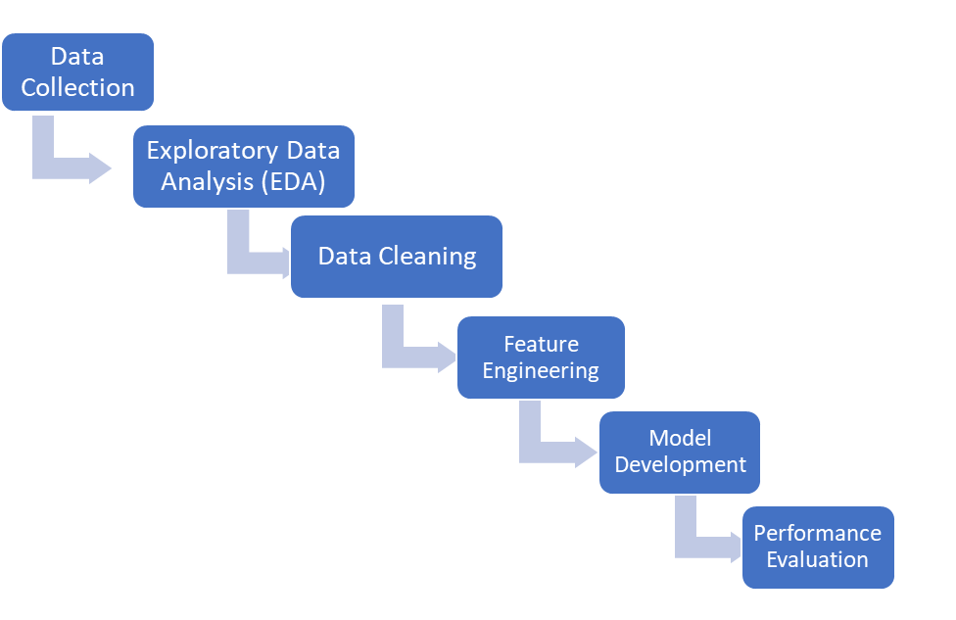

Our approach was to initially explore the data, try to understand the different variables that impact a House price, generate distributions, patterns and trends by performing Univariate and Bivariate analysis which helped us to better understand the data.

Figure 1: Univariate Distribution of Sale Price before and after log transformation

Figure 2: Bivariate Analysis of Sale Price with variable ‘GrLivArea’

Next, we performed Data Cleaning by treating missing values and getting rid of any present outliers. We then performed Feature Engineering to generate new features and remove variables which do not add value in the model. For this we have also plotted a Correlation matrix plot with our response variable which is ‘Sale Price’ and removed those variables which are weakly correlated.

Figure 3: Correlation Plot

Figure 4: Top and Bottom 5 correlated variables

To standardize our features, we have scaled them using the StandardScaler function from Scikit learn.
We have numerous categorical variables which we have handled them by creating dummy variables using the One Hot encode function.

After Data cleaning and Feature engineering we have final 396 variables for building our models.
The next step was to build different machine learning models and evaluate and compare their performances.

- Model Development

We have implemented several Machine learning techniques for performing a comparative analysis. We started with a fairly simple and basic model of prediction which is a Multiple Linear Regression or an OLS model. The training performance had very high Adjusted R-sq value indicating overfitting of the model owing to good performance on Train set but poor performance on the Test set. This is quite possible since we have fitted the model with a very large number of variables on significantly less data points. Such overfitting is likely to occur arising from high model complexity.

To handle this model complexity, we have used Lasso regression which is a L1 regularization algorithm and has a unique property of variable reduction. To find the best values, we have used K-fold cross validation with k=10 and ran the model with 5000 iterations. The rmse performance with this model is the best with a very less rmse value of 0.0004. This can be attributed to the regularization and variable reduction property of Lasso regression.

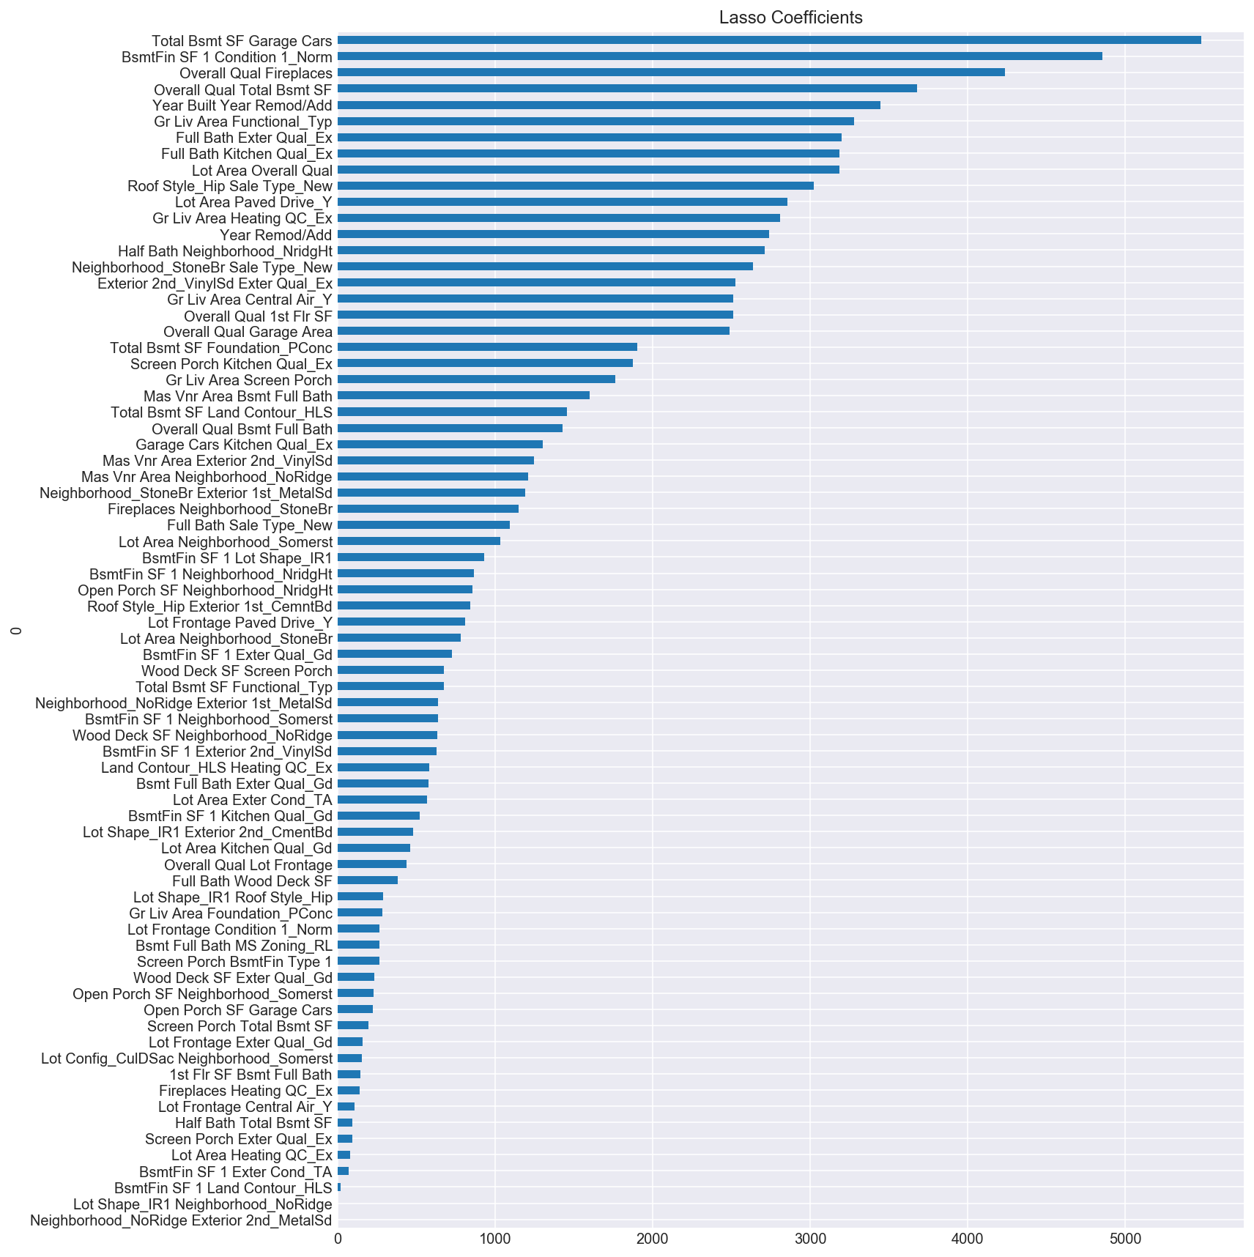
Figure 5: Lasso Coefficients

Further, we have also implemented Elastic Net regression which is a hybrid algorithm of Ridge and Lasso and overcomes their shortcomings. It is trained with L1 and L2 prior as regularizer and is useful when there are multiple features which are correlated. The rmse performance with this algorithm is the second best with a score of 0.00155.

Next, we have applied Support vector regression as the prediction algorithm. SVR is a type of Support vector machine particularly used for handling continuous response variables for prediction. We have made use of the ‘Radial basis kernel’ which is commonly used for handling linear as well as non-linear data. The model performance is however poor with rmse of 0.05. This may be attributed mainly to the fact that kernel models are quite sensitive to overfitting.

Next, we wanted to use Ensemble learning methods as they are quite powerful and can combine several machine learning techniques into one predictive model in order to improve predictions. Ensemble methods can be broadly classified into Sequential ensemble methods such as XgBoost and Parallel ensemble methods such as Random Forest. We have implemented both these 2 types of ensemble methods.
XgBoost is a sequential ensemble technique particularly known for its computational speed and model performance. It is a boosting technique where new models are added to correct the errors made by existing models. Models are added sequentially until no further improvements can be made. The rmse for the XgBoost model is 0.03 which is lesser in comparison to the Lasso and Elastic net algorithms.
For the Parallel Ensemble method, we have implemented Random Forest which is an improvement over Bagged Decision trees. Random Forests build multiple decision trees with random selection of data and variables and then merge them together to get a more accurate and stable prediction. They are quite popular as they have multiple properties such as dimension reduction, missing value and outlier treatment. The model performance in our dataset with random forest is good with rmse of 0.003 but less better than Lasso and elastic net techniques.

The last algorithm that we have implemented on our dataset is an Artificial Neural Network with 2 hidden layers. We have made use of the Keras Deep learning library for constructing our Neural net. For our activation function, we have used ‘ReLu’. The Activation function of a node basically defines the output of that node given a set of inputs. This output is then used as an input for the next node and so on until a desired solution to the original problem is found. There are several other activation functions such as Sigmoid, Hyperbolic Tangent etc which can be used depending on the type of output desired. ‘ReLu’ is the most commonly used activation function which returns 0 for any negative input and for any positive value it returns the value back.

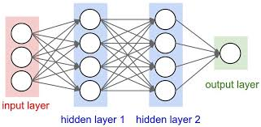
Figure 6: Double layered ANN

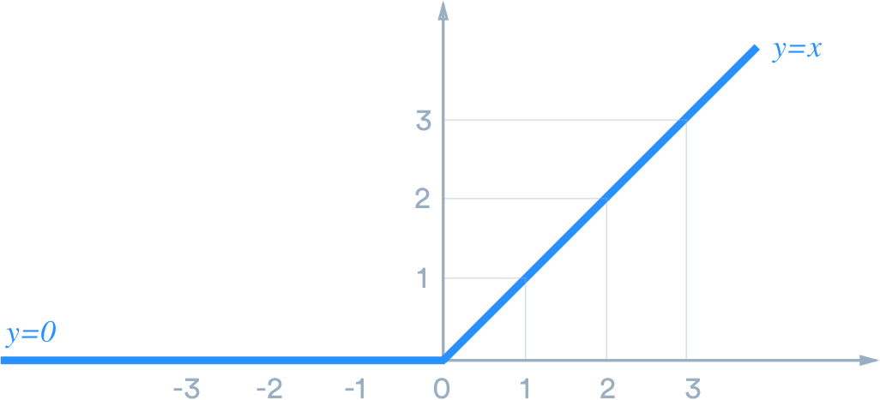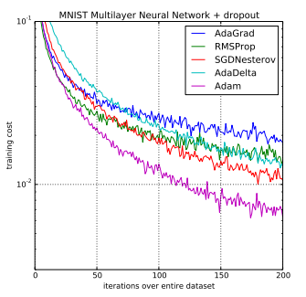
Figure 7: Rectified Linear Unit (ReLu) Figure 8: Adam Vs Other Optimizers

We have chosen ‘adam’ as our optimizer. Optimizers are the algorithms basically used to find optimal sets of weights. With ‘adam’ a learning rate is maintained for each network weight parameter and separately adapted as learning unfolds. Adam is quite popular owing to its advantages such as ease of implementation, computationally efficiency, less memory requirements and its applicability to problems with very noisy/sparse gradients.

The loss function we have made use of is the ‘mean squared error’ which is an evaluation method to check how well our algorithm models the dataset. Mean squared error is quite popular for continuous response variables and is easy to understand and implement. To calculate MSE, we have taken the difference between our predictions and the actual values then squared it and averaged it across the whole dataset. The other loss functions used in other cases are Logarithmic loss, Binary or categorical cross entropy. The model performance with this 2 layered neural net is however quite poor on the training set with a very high rmse of 0.35. This performance can be attributed to high bias of the network. One of the reasons possibly is that it is somewhat tricky to set up the topology of a neural network in terms of no of layers and no of neurons in each hidden layer. It is unlikely that we would have configured it correctly the first time around and so as a future scope of the project, it would be advisable to appropriately handle this problem of High bias by adopting some of the below methods:
- Adding parameters. Add hidden layers/increase the number of neurons in the hidden layers.
- Decrease the regularization parameter.
- Add more features to the input space if possible.

- Results

We have tried to solve the following problem: given a processed list of features for a house, we have tried to predict its potential sale price. Multiple Linear regression is a natural choice of baseline model for regression problem. So, initially we ran Multiple Linear and then explored other Machine Learning techniques. The performance was measured by Root Mean Square Error (rmse) of the predicted results and the actual results. Our baseline model which was Multiple Linear Regression showcased overfitting with a very high adjusted R-sq value and very small rmse. This could be attributed to model overfitting because of the overtly complex model arising from a high number of variables and low data points (1460).

To regularize the model, handle model complexity and minimize overfitting, we used Lasso regression which has a unique property of variable reduction. The model performance of Lasso regression is the best with least rmse of 0.0004 which could be attributed to the regularization and variable reduction property of Lasso regression.

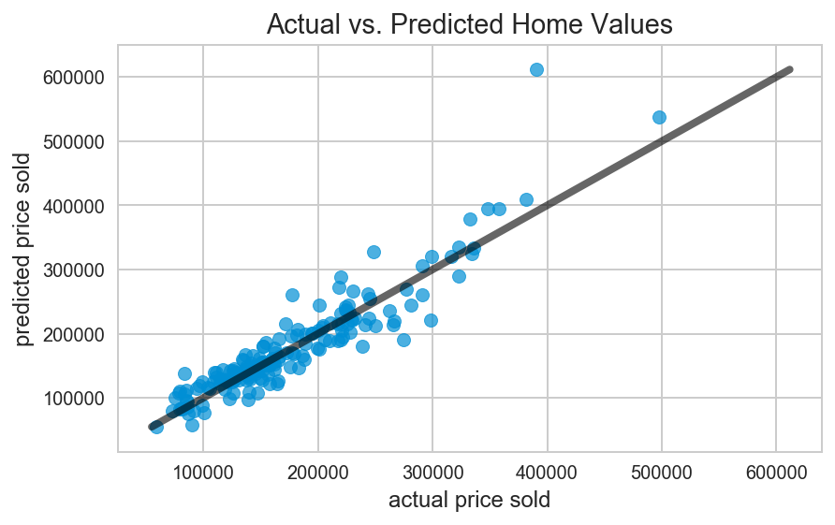
Figure 9: Actual Vs Predicted Plot for Lasso regression

Next, we used ElasticNetCV algorithm on our training data which has the second-best performance with a rmse value of 0.0015. After that we wanted to fit our data on ensemble methods and hence we ran our model with XgBoost and Random Forest. Both have a decent rmse score of values 0.03 and 0.003 but lesser as compared to the regularization algorithms of Lasso and ElasticNet.
We also ran our model using the Support Vector regression algorithm with a radial kernel. The performance is poor with a high rmse of 0.05
Since, the data is high dimensional, we intended to build a 2-layered artificial neural network model. The activation function we used is ‘relu’ with ‘adam’ as the optimizer for finding the optimal weights and ‘mean squared error’as the loss function. The performance of this model is quite poor as compared to all the prior different techniques with a very high rmse value of 1.353

Figure 10: Performance comparison (rmse)

Below is the summarized table with their rmse performances in order of best to worst for the different techniques used:

Machine Learning Method | RMSE performance
Lasso Regression | 0.0004
Elastic Net Regression | 0.0015
Random Forest | 0.003
XgBoost | 0.0306
Support Vector Regression | 0.0506
Artificial Neural Network | 0.35

- Conclusion

This project gave us an opportunity to explore a complex dataset having a large number of features, apply variable selection and variable reduction techniques and understand several Machine learning algorithms, their cost functions, evaluation metrics etc and build those models from scratch.

Post our model development cycle we observed that Lasso Regression is the best performing model far outweighing the performance of all other models. This superior performance can be attributed to its regularization property of variable reduction on complex datasets having large number of variables.
Also, the lasso regression model can provide insights about chosen features which is helpful in understanding the correlations of house features and its sale price.

According to our analysis, living area square feet, material of the roof, and neighborhood have the greatest statistical significance in predicting a house’s sale price.

- Future scope

For Random Forest Regression, besides the depth, we might need to examine further variations to optimize this algorithm, such as considering the splits of nodes, the requirements of leaf nodes, etc.
With Artificial Neural network we could further refine the developed model by adding more layers and more neurons in those hidden layers, add more features to the input space and possibly work with the regularization parameter.
Additionally, we could have further explored the Feature engineering part by removing/adding new variables to our dataset.

References

[1] Lippmann, R.P., 1987. An introduction to computing with neural nets. IEEE Accost. Speech Signal Process. Mag., April: 4-22

[2] N. Murata, S. Yoshizawa, and S. Amari, ―Learning curves, model selection and complexity of neural networks, ‖ in Advances in Neural Information Processing Systems 5, S. Jose Hanson, J. D. Cowan, and C. Lee Giles, ed. San Mateo, CA: Morgan Kaufmann, 1993, pp. 607-614

[3] XGBoost Documentation - xgboost 0.81 documentation - https://xgboost.readthedocs.io/en/latest/
[4] Performance Analysis of Regularized Linear Regression Models - Doreswamy1 and Chanabasayya .M. Vastrad
[5] A Comprehensive guide to Regression - www.analyticsvidhya.com/blog/2015/08/comprehensive-guide-regression/

[6] Support Vector Regression for Prediction of Housing Values - Zhong Yi, Huang Lan, Wang Yan, Yang Bin, Zhou Chunguang

[7] An overview of gradient descent optimization algorithms - http://ruder.io/optimizing-gradient-descent/
[8] Random Forest: Leo Breiman and Adele Cutler - https://www.stat.berkeley.edu/~breiman/RandomForests/cc_home.htm

Team:

Sumit Kumar Gupta – Code development and Report preparation

Nirav Patel –

Ameya Patankar –

